PUBLIC CONSULTATION

Public consultation on the draft Professional practice profile for pharmacists undertaking complex compounding

Submitted by

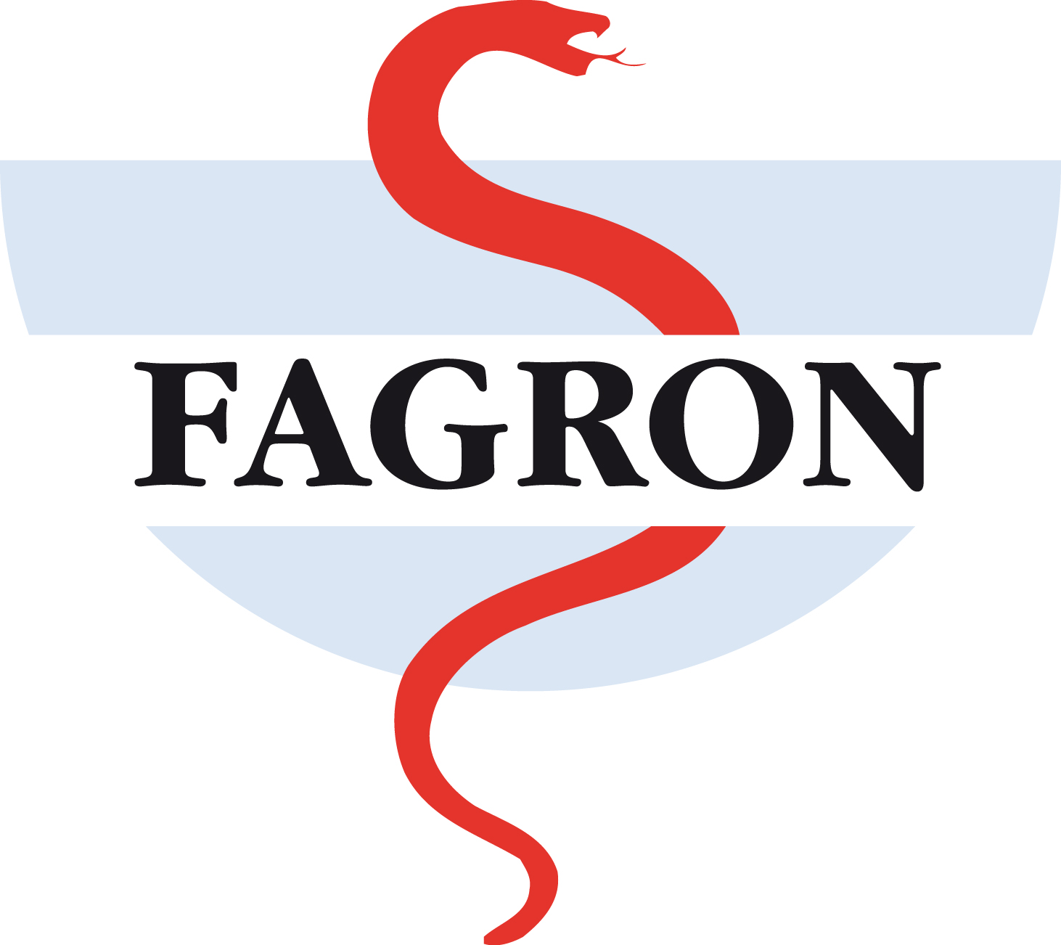

Optimise and Innovate Compounding

June 2014

Contactperson: Brianna Knowles
[content redacted]

- About Fagron

Fagron was founded in Rotterdam (the Netherlands) in 1990 by Ger van Jeveren, the current CEO of the Fagron Group. Through a continuous focus on innovation, quality and solution-oriented thinking, Ger van Jeveren brought market leadership in pharmaceutical compounding to Fagron in the Netherlands in just 7 years and continued to direct further development and international growth, with the result that Fagron is currently the global market leader and active in 30 countries in Europe, the Americas, the Middle East, Africa, Asia and the Pacific. Fagron products are sold to 200,000 customers in over 60 countries around the world.
With 1,832 employees, Fagron generated a turnover of € 335 million in 2013.

Fagron’s strategy is focused on the optimisation and innovation of pharmaceutical compounding. As a R&D scientific pharmaceutical compounding company, Fagron wants to widen the therapeutic scope of the prescriber to enable tailor-made pharmaceutical care. Through its activities, Fagron supports the unique selling point of the pharmacist and improves the patient’s quality of life.
As the only multinational one-stop-solution for pharmaceutical compounding, Fagron develops innovative concepts and solutions that respond to the specific and individual wishes of compounding pharmacies all over the world. In Fagron’s Innovation department, over 200 pharmacists are dedicated to developing and providing innovative concepts, products and formulas that will meet the demands of the pharmacist, prescriber and patient.
Fagron supplies semi finished products for use in pharmaceutical compounding, such as aqua purificata, basic solutions, powder mixtures, cream and ointment bases and vehicles. Fagron also offers high-quality pharmaceutical raw materials to pharmacies and to the industry. In addition, the product range also offers all equipment, instruments and accessories used by pharmacists for efficient pharmaceutical compounding. This includes scales, pestle and mortars, ointment mills, packaging equipment and packaging materials.
With our dedication to optimising and innovating compounding, we have developed and have introduced a new and extensive generation of innovative vehicles globally.

- Fagron vision on compounding

The most important reason why compounded medications are prescribed is “patient non-compliance”. This means that patients are for instance allergic to certain preservatives, dyes, and drug strengths or have problems swallowing capsules, and therefore require alternatively developed medications.
Compounding pharmacists are able to make a variety of changes to traditional medications, including:
• Lower levels or elimination of dyes, preservatives, etc.
• Increased or decreased dosage strengths for infants or elderly people
• Alternative forms of medications, such as troches, lozenges, candies, gels and liquids
• Added flavours for better taste & easier ingestion
Besides this, pharmaceutical compounding also offers a solution to patients who require medications that have been discontinued by drug manufacturers or helps patients who may be facing a supply shortage of their normal medications.

3. Responses to consultation questions

- Does the draft practice profile clearly explain its purpose, and how it should be used in relation to complex compounding?
The draft practice profile is very detailed and explains clearly the purpose of it.

- Is there any content that needs to be changed, added or deleted in the draft practice profile in relation to complex compounding?
The draft is well structured in different domains and all subjects are present. Although after reading the text it is not clear in practice what you have to do as pharmacist. The text is vague and there are no examples, numbers, measures, limits, etc. described. Consequently, for a pharmacist there are no concrete tools to measure if he is doing it right or wrong.

Examples of these are the following (but not limited to):
- Multiple references to reporting of ADRs and outcomes of patient treatment with complex compounding products. Not sure if this is something the Pharmacy Board is going to release nationally or just something each pharmacy keeps a record of for themselves?
- Pharmacists are required to establish with consumers any special services they provide. Is this just verbally or is special signage required for their pharmacy?
- Mention of “appropriate quality” this has to be defined. There are multiple pharmacopoeias but they all range in standards. For example Thyroid extract which complies with the Chinese Pharmacopoeia is 3 times the strength of those which comply with USP and EP
- Segregation of complex compounding with other pharmacy services, again, needs further definition. Is this simply a different area on a bench? Or a different room? A different building?

There is the risk that multiple interpretations are possible which make it also difficult for the Australian authorities to control if the guidelines are followed.

The table on page 11 is very useful.

- Do you have any suggestions for questions to be answered in Frequently Asked Questions developed by the Board, to assist pharmacists in using the practice profile for complex compounding?
No

- Do you have any other comments on the draft practice profile?
No

