

Pharmacy Board of Australia

Registrant Data

Reporting period: 1 January 2017 – 31 March 2017

Table of contents
Introduction 3
Principal Place of Practice 4
1. Registration Type 4
Age Group 5
4. Registration Type and Sub type 5
Gender 6
5. Registration Type 6
6. Percentage 6

Introduction
The role of the Pharmacy Board of Australia (the Board) includes:
- registering pharmacists and students
- developing standards, codes and guidelines for the pharmacy profession
- handling notifications, complaints, investigations and disciplinary hearings
- overseeing the assessment of overseas trained pharmacists who wish to practise in Australia, and
- approving accreditation standards and accredited courses of study.

The Board’s functions are supported by the Australian Health Practitioner Regulation Agency (AHPRA). For information about legislation governing our operations see About AHPRA at http://www.ahpra.gov.au/About-AHPRA/What-We-Do/Legislation.aspx.
The Board has analysed its registration data and produced a number of statistical breakdowns about registrants to share with the profession and community. The Board shares these breakdowns regularly.
For more information on pharmacy registration, please see the Board’s website http://www.pharmacyboard.gov.au/Registration.aspx

Principal Place of Practice
- Registration Type
  - Registration type and sub type by principal place of practice
Registration Type | Sub Type | ACT | NSW | NT | QLD | SA | TAS | VIC | WA | No PPP | Total
General |  | 493 | 8,391 | 199 | 5,467 | 1,983 | 676 | 6,860 | 3,002 | 313 | 27,384
Provisional |  | 43 | 581 | 21 | 390 | 140 | 51 | 419 | 159 | 5 | 1,809
Limited | Postgraduate training or supervised practice | 1 | 1 |  | 1 | 1 |  | 1 | 1 |  | 6
Non-practising |  | 11 | 275 | 2 | 133 | 48 | 11 | 301 | 55 | 252 | 1,088
Total |  | 548 | 9,248 | 222 | 5,991 | 2,172 | 738 | 7,581 | 3,217 | 570 | 30,287

  - Registration type by principal place of practice percentages
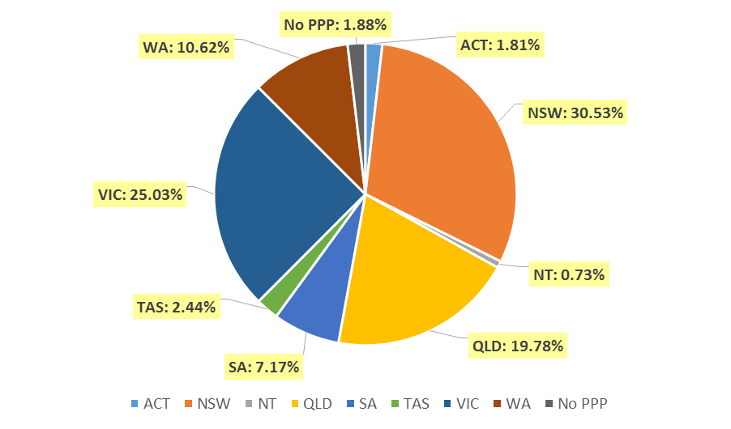

Age Group
- Registration Type and Sub type
  - Registration by age group
Age Group | General | Provisional | Limited | Non-practising | Total
Age Group | General | Provisional | Post graduate training or supervised practice | Non-practising | Total
U - 25 | 1,369 | 1,058 |  | 3 | 2,430
25 - 29 | 5,695 | 455 | 1 | 50 | 6,201
30 - 34 | 5,654 | 166 | 1 | 187 | 6,008
35 - 39 | 4,045 | 72 | 3 | 148 | 4,268
40 - 44 | 2,556 | 35 |  | 115 | 2,706
45 - 49 | 2,163 | 10 |  | 118 | 2,291
50 - 54 | 1,656 | 9 | 1 | 104 | 1,770
55 - 59 | 1,686 | 4 |  | 90 | 1,780
60 - 64 | 1,194 |  |  | 69 | 1,263
65 - 69 | 702 |  |  | 54 | 756
70 - 74 | 370 |  |  | 46 | 416
75 - 79 | 225 |  |  | 52 | 277
80+ | 69 |  |  | 52 | 121
Total | 27,384 | 1,809 | 6 | 1,088 | 30,287

  - Registration by age group

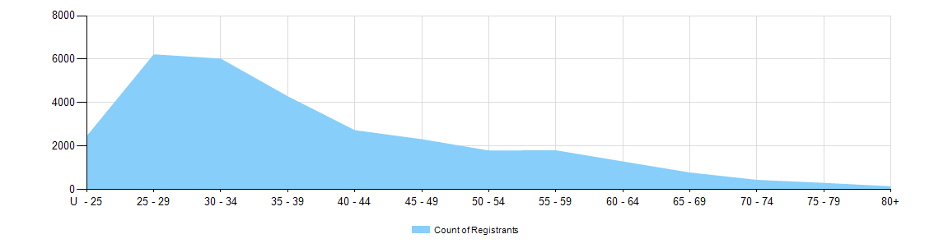

Gender
- Registration Type
  - Gender by state and territory by registration type
Gender | Registration Type | Sub Type | ACT | NSW | NT | QLD | SA | TAS | VIC | WA | No PPP | Total
Female | General |  | 316 | 5,109 | 129 | 3,415 | 1,217 | 396 | 4,201 | 1,903 | 200 | 16,886
Female | Provisional |  | 26 | 377 | 14 | 243 | 91 | 34 | 282 | 107 | 2 | 1,176
Female | Limited | Postgrad training or supervised practice |  | 1 |  | 1 | 1 |  |  | 1 |  | 4
Female | Non-practising |  | 11 | 173 | 2 | 73 | 24 | 7 | 171 | 31 | 171 | 663
Total Female |  |  | 353 | 5,660 | 145 | 3,732 | 1,333 | 437 | 4,654 | 2,042 | 373 | 18,729
Male | General |  | 177 | 3,282 | 70 | 2,052 | 766 | 280 | 2,659 | 1,099 | 113 | 10,498
Male | Provisional |  | 17 | 204 | 7 | 147 | 49 | 17 | 137 | 52 | 3 | 633
Male | Limited | Postgrad training or supervised practice | 1 |  |  |  |  |  | 1 |  |  | 2
Male | Non-practising |  |  | 102 |  | 60 | 24 | 4 | 130 | 24 | 81 | 425
Total Male |  |  | 195 | 3,588 | 77 | 2,259 | 839 | 301 | 2,927 | 1,175 | 197 | 11,558
Total |  |  | 548 | 9,248 | 222 | 5,991 | 2,172 | 738 | 7,581 | 3,217 | 570 | 30,287

- Percentage
  - Registrants by gender percentages
Gender | ACT | NSW | NT | QLD | SA | TAS | VIC | WA | No PPP | Total
Female | 64.4% | 61.2% | 65.3% | 62.3% | 61.4% | 59.2% | 61.4% | 63.5% | 65.4% | 61.8%
Male | 35.6% | 38.8% | 34.7% | 37.7% | 38.6% | 40.8% | 38.6% | 36.5% | 34.6% | 38.2%

