Pharmacy registrant data: March 2015
Published May 2015

Introduction
The role of the Pharmacy Board of Australia (the Board) include:
- registering pharmacists and students
- developing standards, codes and guidelines for the pharmacy profession
- handling notifications, complaints, investigations and disciplinary hearings
- overseeing the assessment of overseas trained pharmacists who wish to practise in Australia, and
approving accreditation standards and accredited courses of study.
The Board’s functions are supported by the Australian Health Practitioner Regulation Agency (AHPRA). For information about legislation governing our operations see About AHPRA at http://www.ahpra.gov.au/About-AHPRA/What-We-Do/Legislation.aspx.
The Board has analysed its registration data and produced a number of statistical breakdowns about registrants to share with the profession and community. The Board shares these breakdowns regularly.
For more information on pharmacy registration, please see the Board’s website http://www.pharmacyboard.gov.au/Registration.aspx

Contents
Pharmacists – registration type and sub type by state or territory 3
Pharmacists – percentage by principal place of practice 3
Pharmacists – registration type and sub type by age group 4
Pharmacists – by age group 5
Pharmacists – registration type and sub type by gender 6
Pharmacists – percentage by gender 6

Pharmacists – registration type and sub type by state or territory
Pharmacists |  | Principal place of practice
Registration type | Registration subtype | ACT | NSW | NT | QLD | SA | TAS | VIC | WA | No PPP | Total
General |  | 432 | 8,038 | 190 | 5,141 | 1,909 | 643 | 6,480 | 2,858 | 334 | 26,025
Provisional |  | 27 | 661 | 16 | 433 | 139 | 48 | 402 | 183 | 1 | 1,910
Limited | Postgraduate training or supervised practice |  | 5 |  |  | 2 |  | 1 | 4 | 1 | 13
Non-practising |  | 15 | 262 | 2 | 98 | 45 | 7 | 291 | 56 | 226 | 1,002
Total |  | 474 | 8,966 | 208 | 5,672 | 2,095 | 698 | 7,174 | 3,101 | 562 | 28,950

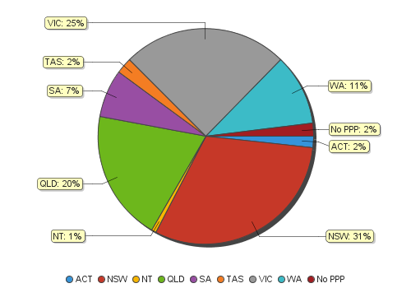
Pharmacists – percentage by principal place of practice

Pharmacists – registration type and sub type by age group
Pharmacists |  | Registration type/ Sub type
Age group | General |  | Provisional | Limited | Non-practising
 |  |  |  | Postgraduate training or supervised practice |  |  | Total
U - 25 | 862 |  | 1,032 |  | 1 |  | 1,895
25 - 29 | 5,524 |  | 559 | 2 | 52 |  | 6,137
30 - 34 | 5,374 |  | 179 | 5 | 142 |  | 5,700
35 - 39 | 3,566 |  | 70 | 1 | 146 |  | 3,783
40 - 44 | 2,446 |  | 38 | 5 | 106 |  | 2,595
45 - 49 | 2,022 |  | 19 |  | 106 |  | 2,147
50 - 54 | 1,708 |  | 5 |  | 117 |  | 1,830
55 - 59 | 1,733 |  | 6 |  | 69 |  | 1,808
60 - 64 | 1,154 |  | 2 |  | 66 |  | 1,222
65 - 69 | 835 |  |  |  | 49 |  | 884
70 - 74 | 460 |  |  |  | 50 |  | 510
75 - 79 | 274 |  |  |  | 48 |  | 322
80+ | 67 |  |  |  | 50 |  | 117
Total | 26,025 |  | 1,910 | 13 | 1,002 |  | 28,950

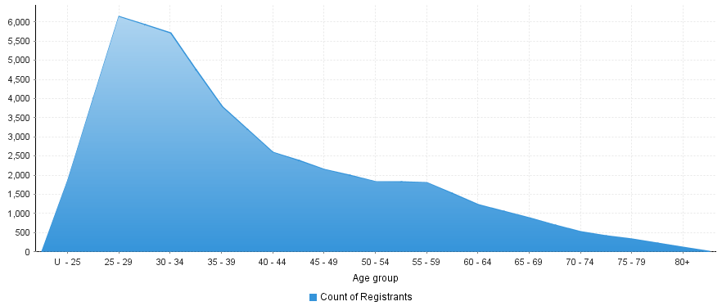
Pharmacists – by age group
Age group | U - 25 | 25 - 29 | 30 - 34 | 35 - 39 | 40 - 44 | 45 - 49 | 50 - 54 | 55 - 59 | 60 - 64 | 65 - 69 | 70 - 74 | 75 - 79 | 80+
Count of registrants | 1,895 | 6,137 | 5,700 | 3,783 | 2,595 | 2,147 | 1,830 | 1,808 | 1,222 | 884 | 510 | 322 | 117

Pharmacists – registration type and sub type by gender
Pharmacists |  |  | Principal place of practice
Gender | Registration type | Registration subtype | ACT | NSW | NT | QLD | SA | TAS | VIC | WA | No PPP | Total
Female | General |  | 281 | 4,790 | 121 | 3,140 | 1,146 | 356 | 3,878 | 1,767 | 204 | 15,683
 | Provisional |  | 18 | 431 | 6 | 290 | 85 | 32 | 265 | 132 | 1 | 1,260
 | Limited | Postgraduate training or supervised practice |  | 5 |  |  | 2 |  | 1 | 4 |  | 12
 | Non-practising |  | 13 | 174 | 1 | 57 | 22 | 4 | 164 | 32 | 152 | 619
Sub Total |  |  | 312 | 5,400 | 128 | 3,487 | 1,255 | 392 | 4,308 | 1,935 | 357 | 17,574
Male | General |  | 151 | 3,248 | 69 | 2,001 | 763 | 287 | 2,602 | 1,091 | 130 | 10,342
 | Provisional |  | 9 | 230 | 10 | 143 | 54 | 16 | 137 | 51 |  | 650
 | Limited | Postgraduate training or supervised practice |  |  |  |  |  |  |  |  | 1 | 1
 | Non-practising |  | 2 | 88 | 1 | 41 | 23 | 3 | 127 | 24 | 74 | 383
Sub Total |  |  | 162 | 3,566 | 80 | 2,185 | 840 | 306 | 2,866 | 1,166 | 205 | 11,376
Total |  |  | 474 | 8,966 | 208 | 5,672 | 2,095 | 698 | 7,174 | 3,101 | 562 | 28,950

Pharmacists – percentage by gender
Pharmacists | Principal place of practice
Gender | ACT | NSW | NT | QLD | SA | TAS | VIC | WA | No PPP | Total
Female | 65.82% | 60.23% | 61.54% | 61.48% | 59.90% | 56.16% | 60.05% | 62.40% | 63.52% | 60.70%
Male | 34.18% | 39.77% | 38.46% | 38.52% | 40.10% | 43.84% | 39.95% | 37.60% | 36.48% | 39.30%

