Pharmacy Registrant Data: September 2014

Published November 2014

Introduction

The functions of the Pharmacy Board of Australia include:
- registering pharmacists and students
- developing standards, codes and guidelines for the pharmacy profession
- handling notifications, complaints, investigations and disciplinary hearings
- overseeing the assessment of overseas trained pharmacists who wish to practise in Australia
- approving accreditation standards and accredited courses of study.

The Board’s functions are supported by the Australian Health Practitioner Regulation Agency (AHPRA). For information about legislation governing its operations see AHPRA's Legislation & Publications at http://www.ahpra.gov.au/Legislation-and-Publications.aspx

The Board has analysed its registration data and produced a number of statistical breakdowns about registrants to share with the profession and community. The Board shares these breakdowns quarterly.

For more information on pharmacy registration, please see the Board’s website:
www.pharmacyboard.gov.au/Registration.aspx

Table of contents

Pharmacists – registration type and sub type by state or territory 3
Pharmacists – percentage by principal place of practice 3
Pharmacists – registration type and sub type by age group 4
Pharmacists – by age group 5
Pharmacists – registration type and sub type by gender 6
Pharmacists – gender percentages 6

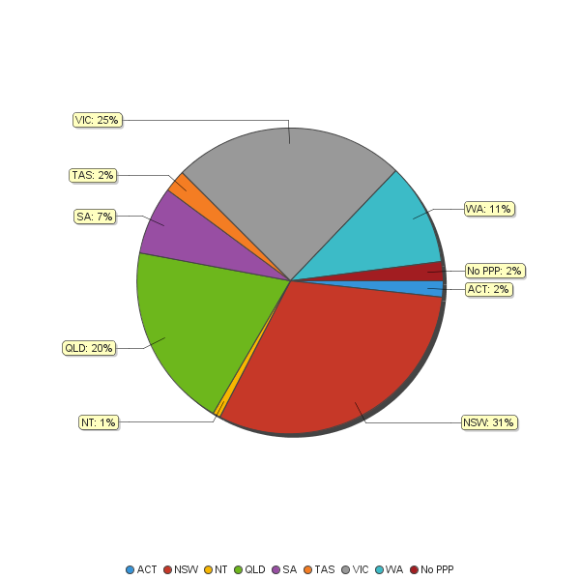

Pharmacists – registration type and sub type by state or territory
Pharmacists |  | Principal place of practice
Registration type | Registration subtype | ACT | NSW | NT | QLD | SA | TAS | VIC | WA | No PPP | Total
General |  | 440 | 7,909 | 187 | 5,062 | 1,866 | 626 | 6,359 | 2,824 | 352 | 25,625
Provisional |  | 34 | 603 | 17 | 421 | 130 | 48 | 360 | 182 | 1 | 1,796
Limited | Postgraduate training or supervised practice |  | 5 | 2 | 3 | 1 |  | 3 | 2 | 1 | 17
Non-practising |  | 11 | 257 | 4 | 95 | 43 | 8 | 277 | 59 | 211 | 965
Total |  | 485 | 8,774 | 210 | 5,581 | 2,040 | 682 | 6,999 | 3,067 | 565 | 28,403

Pharmacists – percentage by principal place of practice

Pharmacists – registration type and sub type by age group

Pharmacists | General | Provisional | Limited | Non-practising
Age group |  |  | Postgraduate training or supervised practice |  | Total
U - 25 | 945 | 1,018 |  | 2 | 1,965
25 - 29 | 5,737 | 507 | 6 | 52 | 6,302
30 - 34 | 5,065 | 148 | 5 | 130 | 5,348
35 - 39 | 3,325 | 63 | 3 | 132 | 3,523
40 - 44 | 2,370 | 34 | 2 | 104 | 2,510
45 - 49 | 1,925 | 17 |  | 94 | 2,036
50 - 54 | 1,782 | 3 |  | 112 | 1,897
55 - 59 | 1,693 | 5 | 1 | 68 | 1,767
60 - 64 | 1,132 | 1 |  | 64 | 1,197
65 - 69 | 838 |  |  | 57 | 895
70 - 74 | 477 |  |  | 51 | 528
75 - 79 | 270 |  |  | 54 | 324
80+ | 66 |  |  | 45 | 111
Total | 25,625 | 1,796 | 17 | 965 | 28,403

Pharmacists – by age group
Age Group | U - 25 | 25 - 29 | 30 - 34 | 35 - 39 | 40 - 44 | 45 - 49 | 50 - 54 | 55 - 59 | 60 - 64 | 65 - 69 | 70 - 74 | 75 - 79 | 80+
Count of Registrants | 1,965 | 6,302 | 5,348 | 3,523 | 2,510 | 2,036 | 1,897 | 1,767 | 1,197 | 895 | 528 | 324 | 111

Pharmacists – registration type and sub type by gender
Pharmacists |  |  | Principal place of practice
Gender | Registration type | Registration subtype | ACT |  | NSW | NT | QLD | SA | TAS | VIC | WA | No PPP | Total
Female | General |  | 293 |  | 4,692 | 116 | 3,046 | 1,114 | 347 | 3,773 | 1,731 | 212 | 15,324
 | Provisional |  | 18 |  | 379 | 12 | 272 | 80 | 25 | 245 | 121 | 1 | 1,153
 | Limited | Postgraduate training or supervised practice |  |  | 5 | 1 | 2 | 1 |  | 2 | 2 |  | 13
 | Non-practising |  | 9 |  | 167 | 2 | 60 | 24 | 5 | 156 | 39 | 143 | 605
Sub Total |  |  | 320 |  | 5,243 | 131 | 3,380 | 1,219 | 377 | 4,176 | 1,893 | 356 | 17,095
Male | General |  | 147 |  | 3,217 | 71 | 2,016 | 752 | 279 | 2,586 | 1,093 | 140 | 10,301
 | Provisional |  | 16 |  | 224 | 5 | 149 | 50 | 23 | 115 | 61 |  | 643
 | Limited | Postgraduate training or supervised practice |  |  |  | 1 | 1 |  |  | 1 |  | 1 | 4
 | Non-practising |  | 2 |  | 90 | 2 | 35 | 19 | 3 | 121 | 20 | 68 | 360
Sub Total |  |  | 165 |  | 3,531 | 79 | 2,201 | 821 | 305 | 2,823 | 1,174 | 209 | 11,308
Total |  |  | 485 |  | 8,774 | 210 | 5,581 | 2,040 | 682 | 6,999 | 3,067 | 565 | 28,403

Pharmacists – gender percentages

Practitioners | Principal place of practice
Gender | ACT | NSW | NT | QLD | SA | TAS | VIC | WA | No PPP | Total
Female | 65.98% | 59.76% | 62.38% | 60.56% | 59.75% | 55.28% | 59.67% | 61.72% | 63.01% | 60.19%
Male | 34.02% | 40.24% | 37.62% | 39.44% | 40.25% | 44.72% | 40.33% | 38.28% | 36.99% | 39.81%

